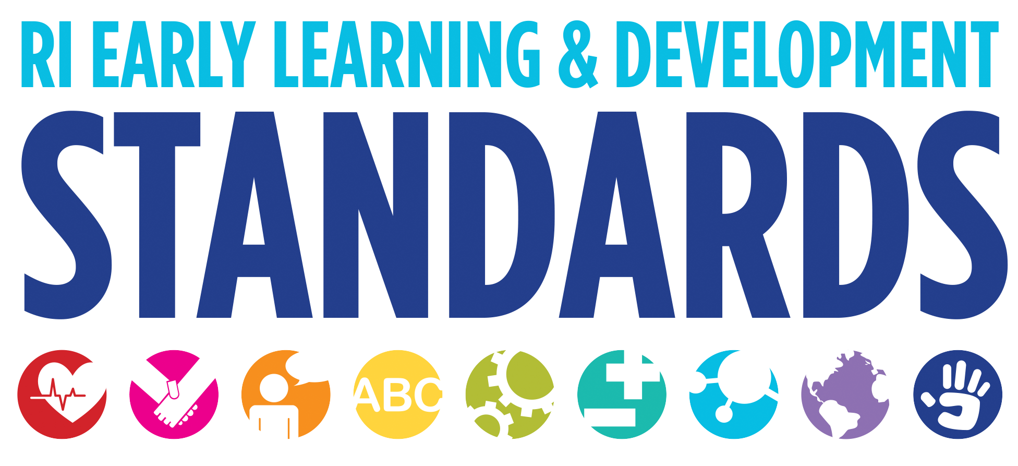
Strategies that Support Children in the Area of Social Studies

Self, Family, and Community
- Dramatize stories from children’s cultures. Ask families to share traditional stories from their cultures.
- Create a flexible environment that stimulates children’s imaginations with appropriate and varied props, furniture, and materials and enough space and time for children to get fully involved.
- Use laundry baskets to use for dumping and filling; climbing in and out (explore spatial relationships); trying to pull up on, push or carry (explore balance) push-pull (cause and effect) pushing smaller objects through holes (fine motor skills); “helping” with chores by collecting laundry.
- Provide props of varying realism to meet the needs of both inexperienced and capable players, including realistic props (cash register, stethoscopes, dolls, coins, and a variety of dress-up clothes) and open-ended objects (cardboard tubes, unit blocks, or pieces of cloth).
- Observe children’s play to learn what they might need to enhance their play—additional props, a suggested action for one of the players, or a subtle comment to take the play to the next level.
- Observe children to determine what they might need to join in the play.
- Help children identify emotions or problems that are surfacing in their dramatic play or drama work.
- In teacher-guided drama, ask questions that encourage problem solving such as, “How can we get past the cave without waking up the bear?”
- Use scaffolding to provide just the right amount of support. For example, teachers can (Davidson 1996):
~ model how to pretend or act out a part through words and actions;
~ model how to use a prop;
~ model the type of conversation that takes place in the setting (“Dr., I have a sore arm. Can you x-ray it for me?”);
~ make comments that help children notice what each other is doing;
~ assume a role and join in to show children that pretend play is important and to introduce new ideas they might want to use in their play; and
~ intervene in disagreements when necessary to prevent physical harm.
Create prop boxes focused on a specific theme such as post office, firehouse, health clinic, or pet store.
- Structure the activities to accommodate young children’s involvement and encourage creativity when leading a story dramatization. For example,
~ allow for the story plot to change as you encourage and include the children’s ideas;
~ break the story plot into a series of short scenes or experiences to keep the children focused and involved.
- Engage each child by having all of them play the same role. In Maurice Sendak’s “Where the Wild Things Are”, all children can pretend to be Max, making mischief, transforming his room, and sailing on an imaginary boat. When they arrive at the place where the wild things are, they all can switch roles and become “Wild Things” making a wild rumpus.
- Allow children to create their own ending for a story; “How do you think the cap seller got those monkeys to give him back his cap? Show me!” This encourages creativity.
- Consider having the children act out a story before you read the book to them.
- Compare the children’s dramatization of a story with the illustrated book and discuss how they were the same or different (Brown & Pleydell 1999).

Self, History and Geography
- Encourage recall and sequencing skills by asking them to tell you what happened in their drama: “How did the story start?” “What happened next?”
- Talk to children about familiar building and signs you see while on a walk or while on the playground.
- Use terms such as “today”, “tomorrow” and “next” in every day interactions.
- Create drawings or simple maps of home, school and other familiar settings.
- Model the language of cooperation for children—“I would like to have a turn” or “May I play in your car?”
- Involve children’s families in every aspect of the program so that children can learn about and compare each other’s personal characteristics, experiences, and cultures.
- Demonstrate respect for various cultures and languages, making sure that children’s home languages and cultures are reflected in books, signs, and learning experiences.
- Write class books about the children’s families, homes, mealtimes, pets, and other aspects of their lives. Discuss what is the same and different about the children’s families.
- Invite parents and family members to share songs they heard as children. Learn and sing songs in child’s home language.
- Coach individual children who need help playing cooperatively with others. Give the child specific words to say or strategies for entering a play situation, demonstrating how to share a toy or how to take on a role.
- Engage children in group discussions and role play how to resolve conflicts or negotiate social problems before they arise.

The Head Start Leader’s Guide. 76-77

