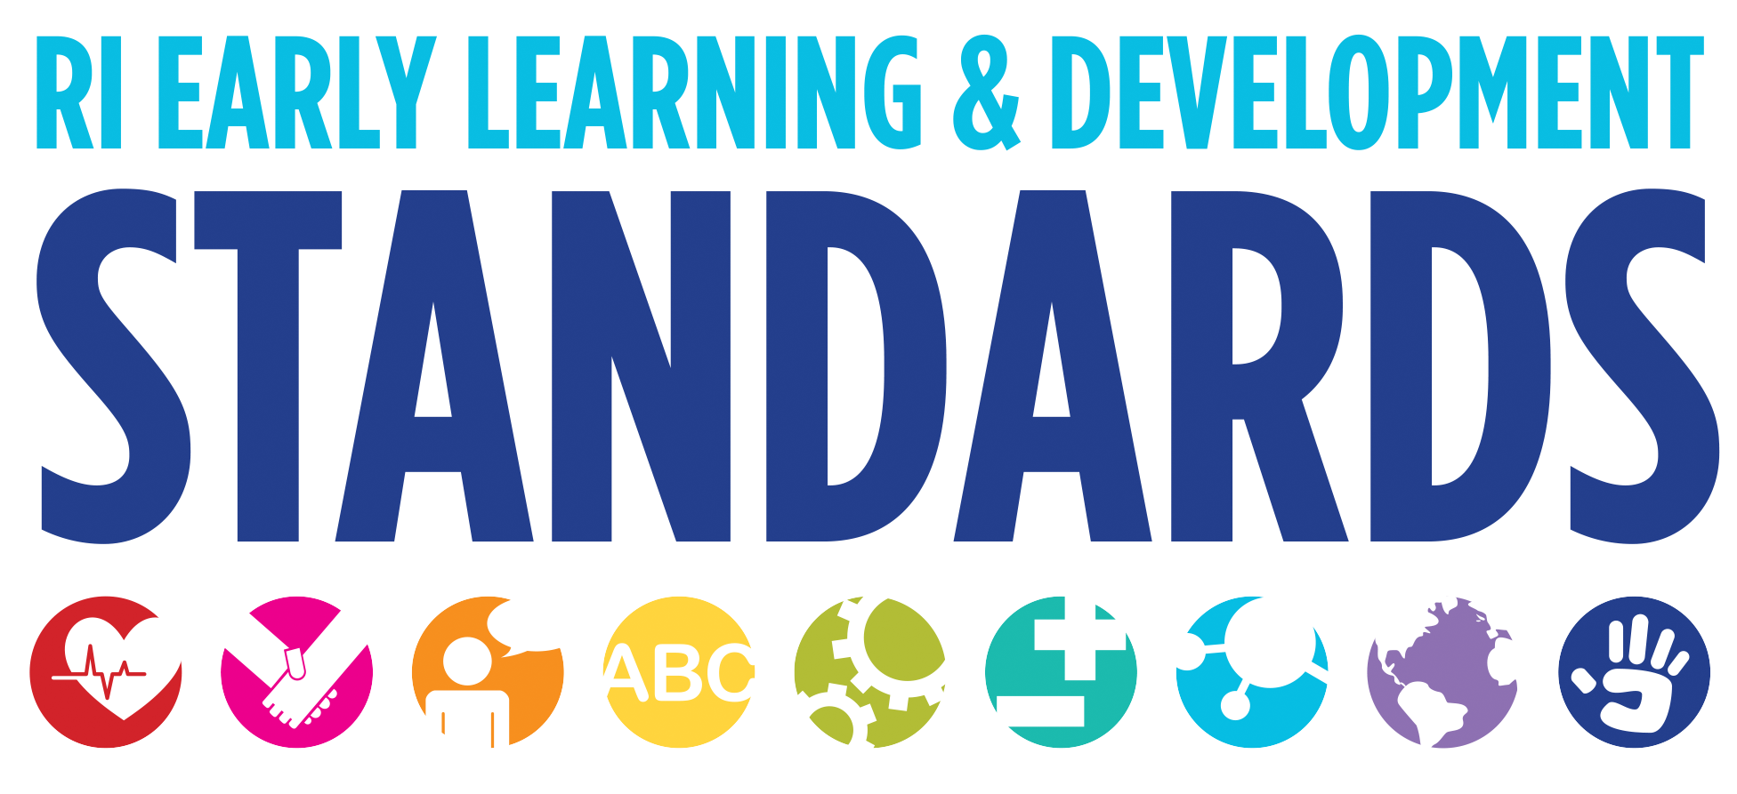
Strategies that Support Children in the Area of Social and Emotional Development

Relationships with Others
- Build relationships with parents so that children feel safe, secure, and comfortable with their teachers.9
- With infants and toddlers create trusting relationships that allow them to be ready and willing to explore.
- When an adult responds to a fussing baby and picks him up, holds him close and sings a gentle song he is supporting the baby’s emotional self-regulation. Babies need adults who can help them learn this skill.
- Build a caring community within the program so that children come to know and feel comfortable with administrators, other teachers, staff, and parents.10
- Provide opportunities for children to work and play together. Successful relationships need both time and content—something to do or think about together.11
- Draw children’s attention to the feelings or experiences of others by saying, “Look at her face. Can you tell how she feels?” Help them to develop empathy by reminding them of their own similar feelings or experiences: “You know what it feels like when someone says you can’t play.”12

Sense of Self
- Provide paint, crayons, markers, and construction paper in various skin tones.1
- Make sure the learning environment is welcoming to every child and reflects his identity and culture. Use photos of children and family members, displays of children’s work, and their names for functional purposes like taking attendance, storing belongings, or assigning jobs.
- Structure the environment to offer opportunities for children to share information about themselves, their families, and experiences. 2
- Give positive feedback and encouragement: “You must feel proud of yourself for . . .” ; “You are a real problem solver for . . .”; “you have worked so hard . . .” 3
- Provide appropriate levels of challenge to work at something and feel a sense of accomplishment. 4

Self-Regulation
- Get to know each child, establish relationships with parents, and support their strengths as well as their needs. 5
- Establish positive, warm, caring relationships with each child, especially those children whose behavior is difficult because they are in greatest need of positive support. 6
- Set clear limits for unacceptable behavior and enforce them with rational explanations in a climate of mutual respect and caring. 7
- Label children’s emotions and your own with simple words such as angry, happy, and sad. Encourage children to name their own emotions. Wait to introduce children to new emotions vocabulary until the heat of the moment has passed. 8
- Talk to parents and family members about the expectations they have for how their child regulates and expresses his emotions. You might ask questions like, "How do you respond when he cries?" or "How do you remind him of rules?" These sorts of open questions will help you get a better idea of how the family supports self-regulation.
- Include family culture, styles, and preferences in your individual planning for each child.
- When infants or toddlers are unable to manage their feelings, offer appropriate support. For example, if a toddler is having a tantrum and does not want to be touched, you can offer a blanket or stuffed animal and calmly sit nearby, ready to help when the child is ready.
- Help children recognize when they do follow directions by encouraging their successes, for example, by making a point of saying, "I noticed you got your jacket the first time I asked. Thank you."
- Use words to describe how children are feeling. Try to expand beyond the positive ("happy" , "silly") and negative ("sad," "angry") to include neutral words ("calm", "patient"). When you tell a child, "You are being so patient waiting for that bottle to warm up," she begins to learn what patient means. Eventually, when you ask her to be patient, she will understand what you want.

1 Diane Trister Dodge, Laura Colker & Cate Heroman. Creative Curriculum for Preschooler. Washington, DC: Teaching Strategies, 2002. 77.
2 U.S. Department of Health and Human Services, Administration on Children, Youth and Families, Head Start Bureau. The Head Start Leader’s Guide to Positive Child Outcomes: Strategies to Support Positive Child Outcomes. (Washington, D.C September 2003) 88.
3 Center on the Social and Emotional Foundations for Early Learning. 2003. http://www.vanderbilt.edu/csefel/
4 The Head Start Leader’s Guide. 88.
5 The Head Start Leader’s Guide. 91.
6 The Head Start Leader’s Guide. 91.
7 The Head Start Leader’s Guide. 91.
8 Ann S. Epstein, The Intentional Teacher: Choosing the Best Strategies for Young Children’s Learning (Washington: NAEYC, 2007) 75.
9 The Head Start Leader’s Guide, 93.
10 The Head Start Leader’s Guide, 93.
11 The Head Start Leader’s Guide, 93.
12 The Head Start Leader’s Guide, 93.

