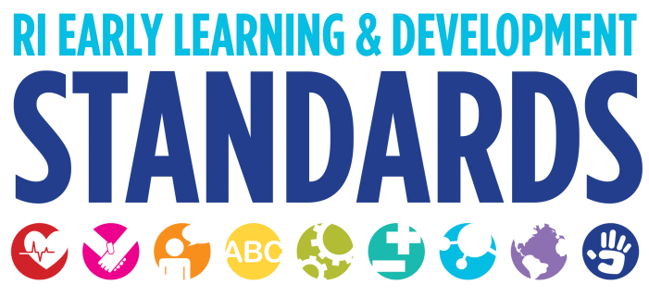
Strategies that Support Children in the Area of Language

Receptive Language and Expressive Language
- Infants are beginning to become familiar with the world of sounds and language around them. Watch as infants turn toward familiar voices or recognize names.
- Respond to infants' coos, gestures, and body movements. These are the beginnings of conversation.
- For children of all ages, experiment with making sounds. For example, with infants you can babble and coo and as children get older you can play with rhyming worlds.
- Babies need many, many opportunities to hear people talk and sing to them so they can figure out the words of their language long before they will be able to speak them. Go beyond singing, be creative, expand the experience to include gestures and puppets or flannel boards
- Model social norms such as saying “please” and “thank you” in everyday routines.
- Model good listening such as maintaining eye contact and expressing interest in the speaker.
- Add descriptions to the words children say. If a toddler points and says, "Truck" you might extend this by saying, “Yes, that is a garbage truck emptying our dumpster," or “I think you hear the sirens of the fire truck."
- Talk directly to children from early infancy. Talk about things you are doing; things you see and hear; things the child is experiencing.
- Read books together from the start. When reading make it a conversation. Even though a young infant cannot speak, they are paying attention to how you ask questions, the picture you point to, and your delight in sharing the experience.
- Play listening games with children. For example, place items in a mystery box for children to identify from clues, and play matching sounds, lotto, and treasure hunt games where children must listen to and follow a series of directions. Games such as “Simon Says” offer opportunities for children to learn specific concepts.
- Build children’s auditory discrimination skills by playing games where the same/different sounds of words are highlighted.
- Provide new and different experiences that expand receptive vocabulary like field trips, visitors, and objects to explore. Afterward, have children describe their experiences in their own words to see what they understand and what new words they’ve learned.
- Read to children every day with the express purpose of enhancing their vocabulary and listening skills. Regularly read in small groups of three to six to ensure children’s active participation. During small group reading, children tend to learn more vocabulary and comprehend the story better.
- Use children’s interests, such as trains or trucks, to identify new words—locomotives, caboose, and dining car, or 18 wheeler, tanker, and pick-up.
- Choose stories or books with rich vocabulary and uncommon words, such as those that preschool children may not hear or use regularly. Take a minute before reading to explain a few of the words that will be new for most children. Point out the new words as they appear in the text.
- Engage in conversations with children about their personal experiences, such as what happened over the weekend.
- Respond to children’s speech with expansions and questions.
- Introduce new words, including the kinds of multi-syllable words that are not typically part of a preschooler’s vocabulary. Use new words numerous times and observe to see if children begin to use them appropriately.
- Engage children in conversations about events, experiences, or people that are beyond the here and now—events from the past, the future, or children’s imaginations (in other words, decontextualized speech). Such interaction requires children and adults to use more complex and varied vocabulary in explanations, descriptions, narratives, dialogue, and pretend talk.
- Talk about a book you are going to read to children before reading it, asking them to predict from the title or cover what the story will be about or what might happen next.
- Talk with children after reading a story; ask them to retell the story or act it out. Encourage them to talk about the characters and events, answering their questions and responding to their comments.
- Point out examples of written words that have meaning to toddlers, such as their name.
- Write down children’s messages to parents or others, dictations for language experience charts, or stories, and read them back.
- Provide dramatic play areas, props, materials, and themes that encourage talking and listening, such as office, post office, bookstore, restaurant, library, supermarket, medical clinic, and construction site.
- Participate in play to get it going if children have difficulty and to extend by including more language interaction. For instance, the teacher may enter the restaurant and pretend to be a customer: “Could I see a menu please. I’d like to order dinner.” In play, children naturally try to imitate adults and their language becomes more complex and sophisticated. They need many opportunities to practice such verbal interaction with other children and occasionally with adults.
- Provide good language models for children. If possible, model standard grammatical speech in the child’s home language. Recognize that many of children’s errors in English (“I wented there, “or “I saw three sheeps“) show their efforts to learn a rule, like the “ed” of the past tense, which they overgeneralize. Instead of correcting the child, pick up on what he says but say it correctly. For example, a child may say, “I gots two foots“ and the teacher replies, “Yes, you have two feet so you need two socks.“

Pragmatics
- Starting with babies, use simple back and forth interactions using eye contact, facial expressions and gestures.
- Demonstrate joined attention by looking with the child at what they are looking at.
- Model body language cues during interactions.
- Encourage children to demonstrate concerns when another child or a pretend toy is injured.
- Encourage adults to model humor by laughing at a funny story or silly incident.

Language Development of Dual Language Learners
- Learn and use words from the child’s home language at the program.
- Have books in the classroom that are written in the child’s home language.
- Talk about books and images which represent both languages and cultures.
- Hang culturally authentic pictures and posters all around the classroom and in the shared hallways and welcome areas. (Note: travel agencies, international tourist offices and bureaus, community organizations, and families can be excellent sources for these items.) Families know from the moment they first enter the building that they are welcomed and respected.
- Provide authentic items from each child's culture and language in all interest areas—not just pictures or toys. Parents have shared empty food containers, menus, games, dolls, musical instruments, clothing, and art supplies from their home countries.
- Books and games in the languages of all the children should be evident. There should be children’s books, catalogs, and games in other languages, some from other countries; classroom volunteers, parents/families may have created others.

The Head Start Leader’s Guide. 76-77

